R Tejashree
Superset ID: 6419704

WEEK 4 – Spring REST using Spring Boot 3

- Part A: Java Database Connectivity (JDBC)
- Part B: Hibernate ORM Basics

Objectives :
- Demonstrate creation of Spring Boot Application
  - Spring initializr, https://start.spring.io, @SpringBootApplication, SpringApplication.run()
    - Ref - https://start.spring.io
- Explain the need and benefits of Spring Boot
  - Makes Java development easy, avoids tedious development steps, reduces development time, avoids writing boilerplate code, provides embedded tomcat server, avoid XML configuration
    - Ref - https://www.journaldev.com/7969/spring-boot-tutorial
- Demonstrate loading bean from spring configuration file
  - Spring configuration xml, spring xml schema spring-beans.xsd, <bean>, id, class, <constructor-arg>, <property>, name, value, ClassPathXmlApplicationContext, ApplicationContext, context.getBean(), singleton scope, prototype scope
    - Ref - https://docs.spring.io/spring-framework/docs/current/spring-framework-reference/core.html
    - IoC Container - https://docs.spring.io/spring-framework/docs/current/spring-framework-reference/core.html#beans
    - Scopes - https://docs.spring.io/spring-framework/docs/current/spring-framework-reference/core.html#beans-factory-scopes
    - Constructor Injection - https://docs.spring.io/spring-framework/docs/current/spring-framework-reference/core.html#beans-constructor-injection
    - Setter method injection - https://docs.spring.io/spring-framework/docs/current/spring-framework-reference/core.html#beans-setter-injection
- Demonstrate inclusion of logging in Spring Boot Application
  - application.properties, logging.level, logging.pattern, server.port, LoggerFactory, Logger, log levels (trace, debug, info, warn, error)
    - Ref - https://docs.spring.io/spring-boot/docs/current/reference/html/boot-features-logging.html

Mandatory Hands-on:
PART A: JDBC Module
Step 1: Open Eclipse
- Launch Eclipse IDE.
- Ensure JDK is properly set up.
Step 2: Create Java Project
- Go to File > New > Java Project
- Name it: jdbc-demo
- Click Finish
Step 3: Add JDBC Driver
- Download the MySQL Connector/J .jar file (or use existing one).
- Right-click on the project > Build Path > Configure Build Path
- Under Libraries tab, click Add External JARs
- Select mysql-connector-java-x.x.xx.jar and click Apply and Close
Step 4: Create Package and Class
- Right-click src > New > Package
- Name: com.cognizant.jdbc
- Right-click the package > New > Class
- Name: JDBCExample
- Check public static void main
Step 5: Write JDBC Code
package com.cognizant.jdbc;

import java.sql.*;

public class JDBCExample {
public static void main(String[] args) {
try {
Class.forName("com.mysql.cj.jdbc.Driver");
Connection con = DriverManager.getConnection(
"jdbc:mysql://localhost:3306/demo", "root", "root"
);

Statement stmt = con.createStatement();
ResultSet rs = stmt.executeQuery("SELECT * FROM employee");

while (rs.next())
System.out.println(rs.getInt(1) + " " + rs.getString(2));

con.close();
} catch (Exception e) {
System.out.println(e);
}
}
}
Step 6: Run the Application
- Right-click the file > Run As > Java Application
- Output will show employee data from the MySQL database
Sample Output in Console:
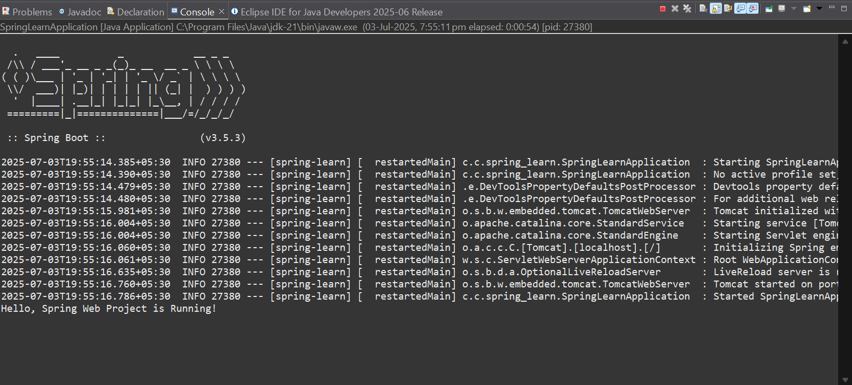
📁 Project Structure Overview:
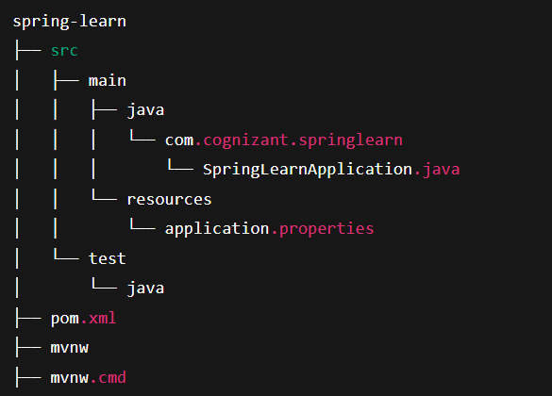
EX1 Create a Spring Web Project using Maven
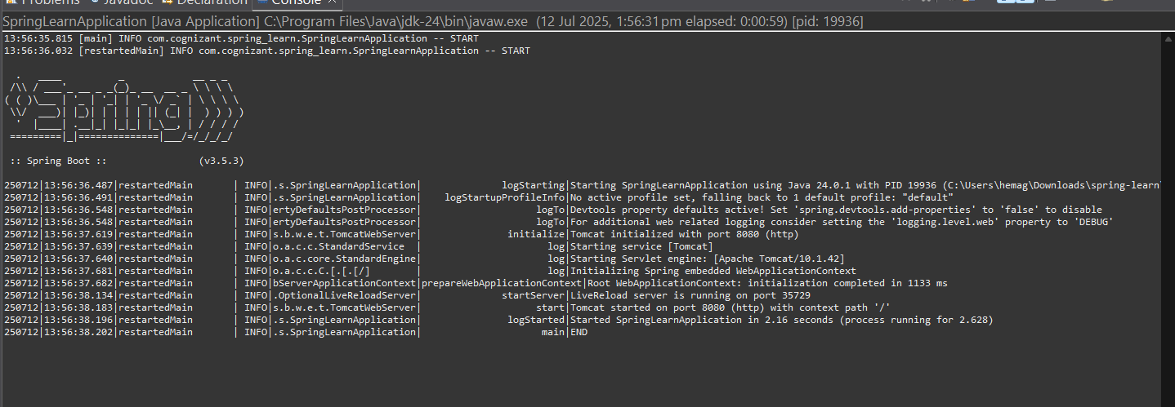

EX1 Hello World
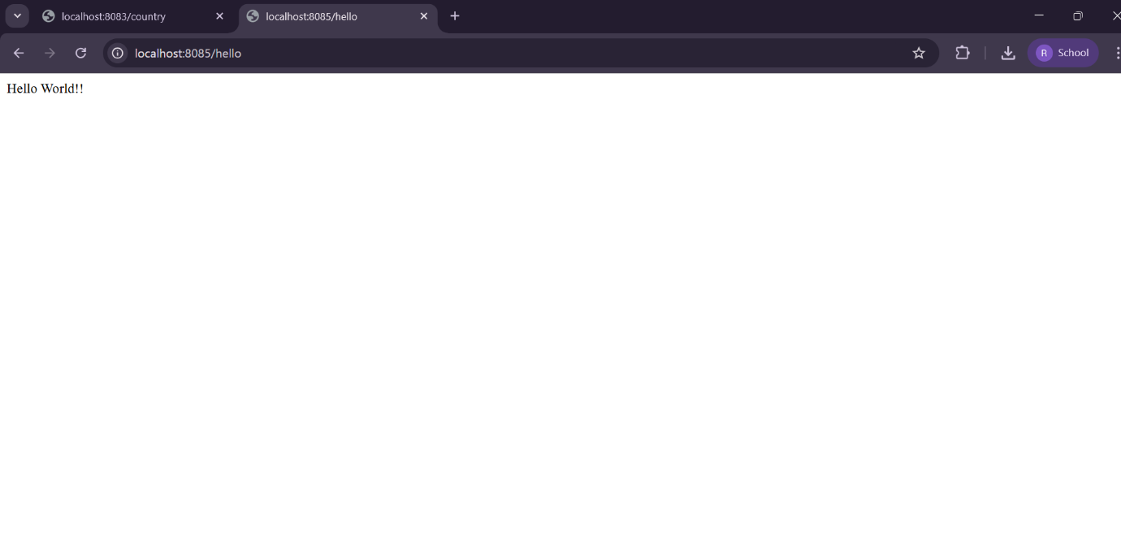

PART B: Hibernate Module
Step 1: Create Maven Project
- Go to File > New > Maven Project
- Choose Simple Project, click Next
- Enter:
  - Group Id: com.cognizant.hibernate
  - Artifact Id: hibernate-demo
- Click Finish
Step 2: Add Dependencies in pom.xml
<dependencies>
<dependency>
<groupId>org.hibernate</groupId>
<artifactId>hibernate-core</artifactId>
<version>5.6.15.Final</version>
</dependency>
<dependency>
<groupId>mysql</groupId>
<artifactId>mysql-connector-java</artifactId>
<version>8.0.33</version>
</dependency>
</dependencies>
Step 3: Create Model Class
java
CopyEdit
package com.cognizant.hibernate.model;

import javax.persistence.*;

@Entity
@Table(name = "employee")
public class Employee {
@Id
private int id;
private String name;

// getters and setters
}
Step 4: Create hibernate.cfg.xml
Place this file in src/main/resources:
<!DOCTYPE hibernate-configuration PUBLIC
"-//Hibernate/Hibernate Configuration DTD 3.0//EN"
"http://hibernate.sourceforge.net/hibernate-configuration-3.0.dtd">
<hibernate-configuration>
<session-factory>
<property name="hibernate.connection.driver_class">com.mysql.cj.jdbc.Driver</property>
<property name="hibernate.connection.url">jdbc:mysql://localhost:3306/demo</property>
<property name="hibernate.connection.username">root</property>
<property name="hibernate.connection.password">root</property>
<property name="hibernate.dialect">org.hibernate.dialect.MySQL8Dialect</property>
<property name="hibernate.hbm2ddl.auto">update</property>
<mapping class="com.cognizant.hibernate.model.Employee"/>
</session-factory>
</hibernate-configuration>
Step 5: Create Main Class
package com.cognizant.hibernate;

import org.hibernate.Session;
import org.hibernate.SessionFactory;
import org.hibernate.cfg.Configuration;
import com.cognizant.hibernate.model.Employee;

public class App {
public static void main(String[] args) {
Configuration cfg = new Configuration().configure();
SessionFactory factory = cfg.buildSessionFactory();
Session session = factory.openSession();

Employee emp = new Employee();
emp.setId(1);
emp.setName("John");

session.beginTransaction();
session.save(emp);
session.getTransaction().commit();

session.close();
factory.close();
}
}
Step 6: Run the Program
- Right-click App.java > Run As > Java Application
- A new employee record should be inserted into the database

EX2 REST - Country Web Service
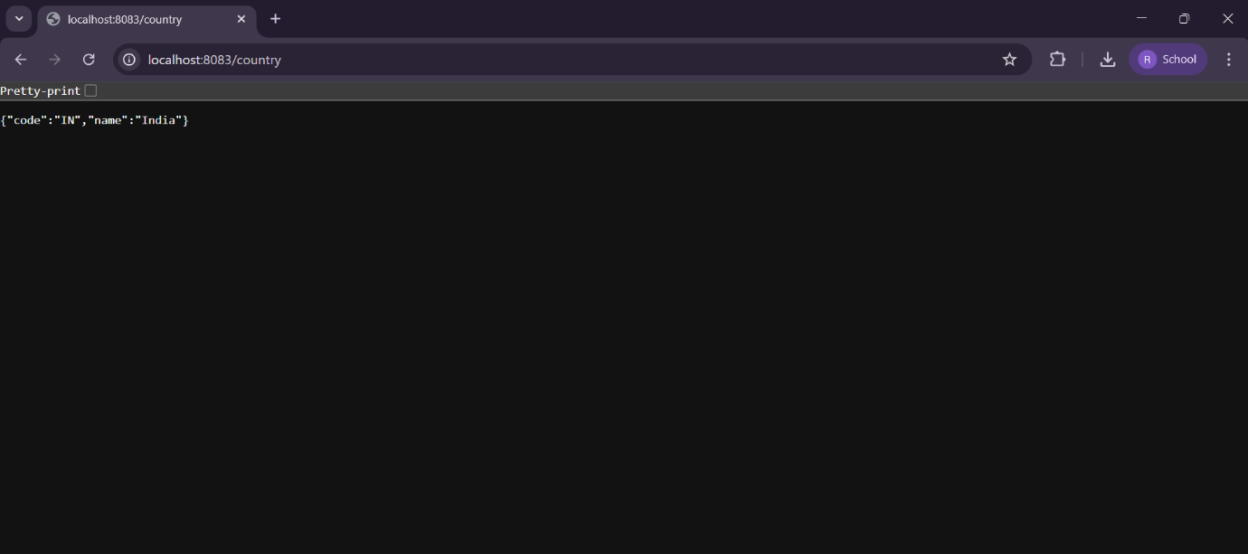
EX3 REST - Get country based on country code
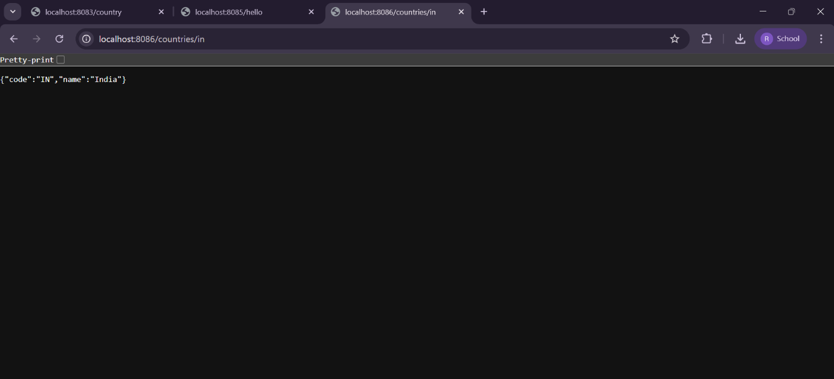

JWT Handson
